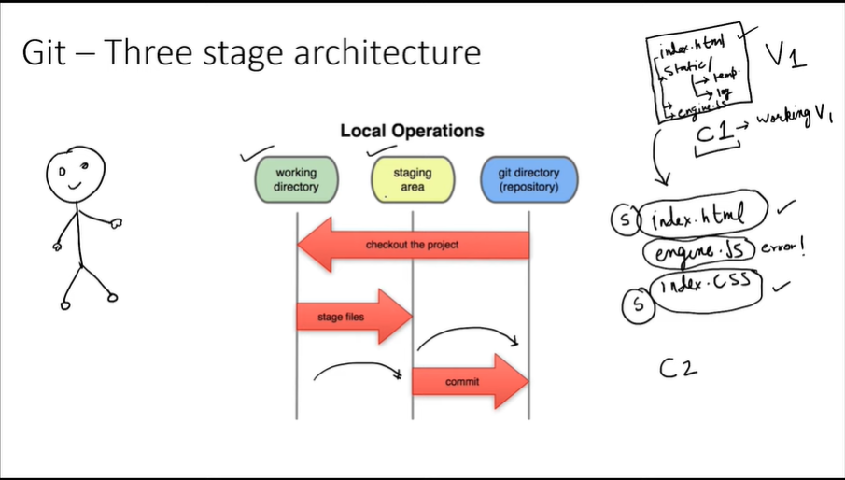

3 stage architecture

To check the status of the git repository

Git status

If suppose it gives an error..then that means that you haven’t initialized a git repository yet.Hence to initialize it we do :-

Git init

Now this command has created a git repo in your cwd and it’s the task of that git repo to keep track of everything in that folder.

Now again,run the command :-

Git status

This time it will show you the status of that cwd.

Now suppose you want to put all the files into the staging area :-

Git add –a

“a” stands for all.The above command will put all files in the staging area.